Social Entrepreneurship

By: Chao Zhang

Nicholas Voordenhout

Mikkel Vlietstra

# Companies Chosen

Kellogg’s

A business focused on profit but also environmentally conscious. Fits on the scale of profit/planet friendly.

3M

Operates as a business focused on profit. Fits on the scale of profit/planet friendly.

TOMS

Non-Profit Organization, focused on environment and people. Fits on the scale of people/planet friendly.

# Companies Background

Kellogg’s is an American multinational food manufacturing company. They have stated that the purpose of their company is “Nourishing families so they can flourish and thrive.” Their products are manufactured in 18 different countries and is marketed globally. They are not a pure for profit corporation as they launched their Breakfasts for Better Days™ program in early 2013. This program is their long-term charitable cause, focusing on global hunger relief and food security. Their goal is to provide 1 billion servings of breakfast and snacks to people in need around the world by the end of 2016. In the first two years of the Breakfasts for Better Days™ initiative, Kellogg Company and the Kellogg Company Fund donated more than 900 million servings of products, of which more than 500 million were breakfast foods. They are also an environmentally aware company. They have been dedicated to reduce energy consumption, greenhouse gas emissions, water use and waste sent to landfill. Their current operational goals are to reduce facilities’ energy use, GHG emissions and water use by 15–20 percent from 2005 to 2015. Decrease waste sent to landfill by 20 percent from 2009 to 2015. They set this new target after achieving a 41.5 percent waste-to-landfill reduction from 2005 to 2009.

3M is not only a company that creates; it is a company that cares. That is why 3M is committed to building sustainable communities around the world through strategic social investments. Our goal is to create a better world for everyone. To that end, last year 3M invested more than $82 million in cash and in-kind donations to support global educational, community and environmental initiatives. These donations were bolstered by the more than 300,000 volunteer hours from 3M employees and retirees around the world.

Tom's Shoes is an organization that helps developing countries by giving portions of sales to children as well as many other things. For every pair of shoes that is purchased at Tom's Shoes, a pair of shoes is donated to a child in another country. Tom's also helps with sight to those who need such surgery, as well as donating safe and clean water and they provide trained birth attendants for child birth. These funds are all raised by selling of shoes, eyewear and bags. The social entrepreneurship level for Tom's Shoes is a Non Profit Organization. They help the people and the environment, donations are essential and recipients might be charged money for services. They have produced over 10 million pairs of shoes in 5 countries and create over 700 jobs in regions where they give with and fair wage. Countries that they produce the Giving Shoes in are Argentina, China, Ethiopia, Haiti, India and Kenya.

# Annual Reports

Kellogg’s 2014 Annual Report

* Net Income - $5.06 Billion
* Net Sales - $14.58 Billion
* Donated more than 900 million servings of products past 2 years

3M’s 2014 Annual Reported

* $4.95 Billion Net income
* $31.83 Billion Net Sales
* Gave $28,902,883 (cash and non-cash) towards education
* Gave $51,437,745 (cash and non-cash) towards community
* Gave $1,856,109 (cash and non-cash) towards the environment
* Total at $82,196,737 overall donations
* Supplied a total of 209,563 volunteer hours

# Comparisons

|  |  |
| --- | --- |
| Profit: | Social Benefit: |
| Kellogg’s | 3M |
| 3M | Kellogg’s |
| TOMS | TOMS |

# Sources

<http://www.forbes.com/sites/jenniferrooney/2012/05/10/kelloggs-embarks-on-major-brand-overhaul/>

<http://www.mediapost.com/publications/article/242068/kellogg-seeks-input-in-new-open-for-breakfast-ca.html?edition>

<https://www.facebook.com/KelloggsCareers>

<https://twitter.com/KelloggsCareers>

<http://investor.kelloggs.com/files/doc_financials/annual_reports/K_2014-Annual-Report_v001_q725z5.pdf>

<http://multimedia.3m.com/mws/media/1081941O/3mgives-annual-report-2014.pdf>

<http://multimedia.3m.com/mws/media/1081941O/3mgives-annual-report-2014.pdf>

<http://investors.3m.com/files/doc_financials/2014/ar/2014_3M_Annual_Report.pdf>

<http://www.toms.ca/static/www/pdf/TOMS_Giving_Report_2013.pdf>

<http://www.toms.ca/stories/>

<http://www.toms.ca/improving-lives>

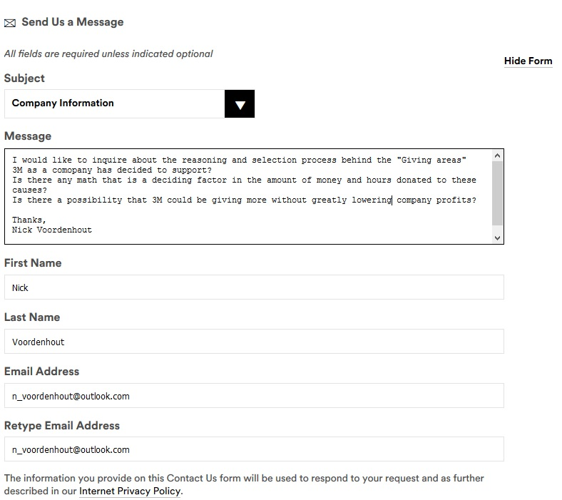E-mail question for 3M

E-mail question for TOMS

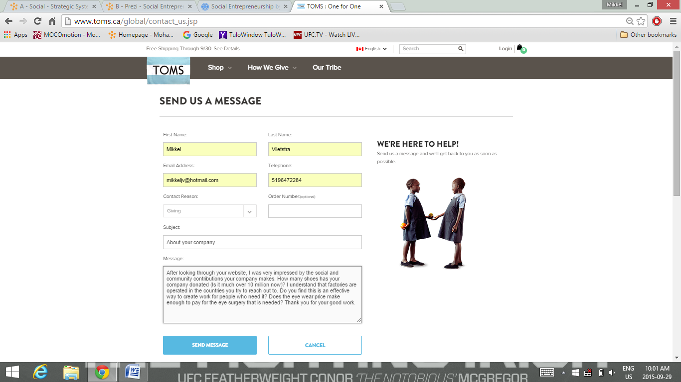

|  |
| --- |
| E-Mail Response  Hi Mikkel,  Thank you for contacting TOMS. We’re glad you’re excited to learn more about the One for One Movement.  Shoe giving is our original give, and it has been an incredible journey. Our One for One giving model for our shoes is simple: with every pair of shoes you purchase, TOMS will give a pair of new shoes to a child in need.Purchases of TOMS Shoes have allowed us to give over 45 million pairs of shoes to children in need, in over 70 countries, across five continents.  Additionally, each TOMS Eyewear purchase (both sun and optical) helps to provide a sight-restoring service by trained medical professionals. Each patient receives a full eye exam, followed by the treatment he or she needs. TOMS supports treatments for three of the most common vision issues:  ·         Sight-saving surgery (for issues such as cataracts) ·         Prescription Glasses ·         Medical Treatments  TOMS has helped restore sight to over 325,000 people in need.  Finally, TOMS shoes are currently manufactured in China, Ethiopia, and Argentina. We require that the factories operate under sound labor conditions, pay fair wages, and follow local labor standards. A code of conduct is signed by all of our factories. Our production staff routinely visits these factories to make sure they are maintaining these working standards. We also have a third party auditor ([www.intertek.com/consumer/auditing/](http://www.intertek.com/consumer/auditing/)) who visits the factories at least once a year to ensure they adhere to proper labor regulations.  We hope this helps! You can learn more about TOMS Corporate Responsibility here:<http://www.toms.com/corporate-responsibility/>  If you have any more questions, concerns, feedback---please let us know! We're available on [chat](http://www.toms.com/contact-information) or by phone: (800) 975-8667  Monday – Friday, 8:00 a.m.- 5:00 p.m. PST  You can also send us a message via email anytime and we will get back to you within 24 to 48 hours. We're also available on Twitter! If you follow us (@TOMSsupport), you'll be able to shoot any questions you may have our way.  Thank you for supporting the One for One Movement!0D50JKsL._50050hiGCI:ref |
| **Thank You,** David T. [http://www.toms.com/support/](https://cs13.salesforce.com/p/email/template/EmailTemplateEditorUi/www.toms.com/support)  US Phone : 800-975-8667 CAN Phone: 800-975-8667 UK Phone : 00+1-702-726-3175 NL Phone : 0-800-720-0007 |